UChicago CCSR Quarterly Metrics Report
January 1, 2015 to April 1, 2015

Introduction
This report will cover some of the basic metrics of UChicago CCSR influence during the period January 1, 2015 to April 1, 2015. Among these metrics are the publications put out by UChicago CCSR, the news items covering research from UChicago CCSR, analytics of UChicago CCR social media work, presentations by UChicago CCSR researchers, and Google Analytics reports on the UChicago CCSR website.

Publications
The term “publications” is a wide umbrella, encompassing UChicago CCSR reports, articles published by UChicago CCSR researchers and affiliates, and papers written by UChicago CCSR researchers. Reports are available on UChicago CCSR website. Many are also available for purchase on Amazon. UChicago CCSR prints a certain number of copies of each report for distribution as well. Articles are also available on the UChicago CCSR website, as they are reported to the web master.

Reports
This quarter, UChicago CCSR released two reports.

Discipline Practices in Chicago Schools: Trends in the Use of Suspensions and Arrests
On March 19, UChicago CCSR released the first in a series of reports about discipline practices in Chicago Public Schools. The report tracks suspension and arrest rates in Chicago schools over a six-year period, as CPS implemented a number of policies intended to improve school climate and reduce the amount of instructional time lost to suspensions. The policies are part of a larger national push to move away from “zero-tolerance” discipline policies and reduce the use of practices that remove students from the classroom.

School Closings in Chicago: Understanding Families’ Choices and Constraints for New School Enrollment
On January 22, UChicago CCSR released a report tracking the enrollment patterns of nearly 11,000 students required to transition to a new elementary schools after the 2013 mass school closings in Chicago. It also draws on interviews with parents to understand how they navigated the enrollment process and why some students ended up in their assigned school while others ended up in schools that were higher- or lower-rated than those assigned to them by the district.

Articles
This quarter, UChicago CCSR researchers published one article.

Teacher Perspectives on Evaluation Reform: Chicago’s REACH Students
Published in Educational Researcher by Jennie Y. Jiang, Susan E. Sporte, and Stuart Luppescu, this article draws on 32 interviews from a random sample of teachers and two years of survey data from more than 12,000 teachers per year to measure their perceptions of the clarity, practicality, and cost of CPS’s new teacher evaluation system, REACH Students.

Book Chapters
This quarter, UChicago CCSR released one book chapter.

Closing the School Discipline Gap: Equitable Remedies for Excessive Exclusion

Daniel J. Losen’s new book, Closing the School Discipline Gap: Equitable Remedies for Excessive Exclusion, features a chapter by Matthew Steinberg, Elaine Allensworth, and David Johnson, titled “What Conditions Support Safety in Urban Schools? The Influence of School Organizational Practices on Student and Teacher Reports of Safety in Chicago.” The chapter focuses on the research from the 2011 UChicago CCSR safety report, Student and Teacher Safety in Chicago Public Schools: The Roles of Community Context and School Social Organization.

Influence
Organizations applying/disseminating UChicago CCSR research (January 1, 2015 to April 1, 2015): 34
Examples:
- The Oregon Mentors website includes a link to the2012 Noncog Report in its list of "Research Articles We Refer To." http://oregonmentors.org/research-articles-we-refer-to/
- Richard Kahlenberg and Halley Potter of the Century Foundation cited Organizing Schools for Improvement in their Educational Leadership article, Smarter Charters, stating "Strong relational trust among teachers and administrators seems crucial to school improvement."
- SRI International wrote to UChicago CCSR, seeking permission to use specific survey items in combination with some original items, as part of a survey for teacher and school leaders.
Consultations/Data Requests/Background Interviews (January 1, 2015 to April 1, 2015): 65
Examples:
- Brent Staples of the New York Times contacted UChicago CCSR to speak with researchers and conduct a background interview about the discipline findings, which were eventually included in an editorial.
- Arnaldo Rivera, Deputy Chief of Staff for Education for the City of Chicago, contacted UChicago CCSR researchers to get their take on a series of education articles.
- Researchers from the Research Alliance for New York City Schools consulted with UChicago CCSR researchers on how to use Rasch to develop a survey, similar to the 5Essentials, for schools in their district.

Collaborations with Organizations Outside of the University (January 1, 2015 to April 1, 2015): 12
Examples:
- UChicago CCSR staffers met with representatives from the Education Writers Association to coordinate content for the annual meeting.
- The Network for College Success, UChicago Impact, and UChicago CCSR joined forces to draft plans for outreach for the next phase of the To & Through outreach.
- Michael Lach of CEMSE and several UChicago CCSR researchers worked together to draft a National Science Foundation grant proposal to study the Common Core in CPS.

News Items
During the quarter, UChicago CCSR reports, researchers, and work were mentioned 91 times in a total of 49 news outlets. Outlets that mentioned UChicago CCSR multiple times include Catalyst Chicago (12), CBS Chicago (2), Chicago Now (2), Chicago Sun-Times (8), Chicago Tonight (3), Chicago Tribune (2), Crain’s Chicago Business (2), DNAinfo (4), Dropout Nation (2), Education Week (7), Hyde Park Herald (4), New York Times (2), The Chicago Maroon (2), and WBEZ (4). These news items cite/link 12 specific UChicago CCSR publications. Additionally, these news items cover several miscellaneous topics—including the 5Essentials, school closings, post-secondary, reform, and the CCSR model—without citing a specific publication.

*One international publication (on the topic of the CCSR model) is not represented on the graph

Discipline Practices in Chicago Schools: Trends in the Use of Suspensions and Arrests
U of C report: Most vulnerable CPS students still suspended at high rates
http://chicago.suntimes.com/education/7/71/452101/u-c-report-vulnerable-students-still-suspended-high-rates-though-cps-overall-suspensions-dropping
Chicago Sun-Times, 3/19/2015

Suspensions down for all CPS students, except Black students, study finds
http://www.dnainfo.com/chicago/20150319/hyde-park/suspensions-down-for-all-cps-students-except-black-students-study-finds
DNAinfo, 3/19/2015

Reporte: Más suspensiones entre alumnos vulnerables en Chicago
http://www.vivelohoy.com/noticias/8437412/reporte-mas-suspensiones-entre-alumnos-vulnerables-en-chicago
Vívelo Hoy, 3/19/2015

Suspensions down, schools feel safer, but charter data still absent
http://catalyst-chicago.org/2015/03/suspensions-down-school-climate-better-but-charter-data-still-absent/
Catalyst Chicago, 3/19/2015

Morning Shift: New U of C report dissects discipline practices in Chicago schools
http://www.wbez.org/programs/morning-shift/2015-03-19/morning-shift-new-u-c-report-dissects-discipline-practices-chicago
WBEZ, 3/19/2015

Discipline in Chicago Public Schools
http://chicagotonight.wttw.com/2015/03/19/discipline-chicago-public-schools
Chicago Tonight, 3/19/2015

Vulnerable Chicago students face frequent discipline, report finds
http://blogs.edweek.org/edweek/District_Dossier/2015/03/suspensions_down_in_chicago_sc.html
Education Week, 3/20/2015

Editorial: Why school suspensions aren't the answer
http://chicago.suntimes.com/politics/7/71/466884/editorial-cps-discipline-2
Chicago Sun-Times, 3/24/2015

CPS suspension rates, men’s health and a community summit in school news
http://hpherald.com/2015/03/25/cps-suspension-rates-mens-health-and-a-community-summit-in-school-news/
Hyde Park Herald, 3/25/2015

Study finds disparities in school discipline in Chicago
http://www.otlcampaign.org/blog/2015/03/25/new-study-discipline-chicago-public-schools
National Opportunity to Learn Blog, 3/25/2015

Backing away from zero tolerance
http://www.nytimes.com/2015/03/26/opinion/backing-away-from-zero-tolerance.html?_r=0
New York Times, 3/26/2015

Suspensions down and school safety climate up in Chicago Public Schools (Not posted to UChicago CCSR website!)
http://lawprofessors.typepad.com/education_law/2015/03/suspensions-down-and-school-safety-climate-up-in-chicago-public-schools.html
Education Law Prof Blog, 3/26/2015

Flexibility, peer review aids school discipline
https://www.cabinetreport.com/human-resources/flexibility-peer-review-aids-school-discipline
Cabinet Report, 3/30/2015

From High School to the Future: Potholes on the Road to College
Chicago Public Schools students at Hancock win Posse Scholarships
http://www.chicagonow.com/white-rhino/2015/02/chicago-public-schools-students-win-posse-scholarships/
Chicago Now, 2/4/2015

Looking Forward to High School and College: Middle Grade Indicators of Readiness in Chicago Public Schools
Leveraging grades and attendance to improve high school success
http://blogs.edweek.org/edweek/college_bound/2015/01/grades_and_attendance_are_best_predicators_of_high_school_success.html
Education Week, 1/13/2015

Take 5: Education assemblies, middle grades to college, Duncan’s pro-testing stance
http://www.catalyst-chicago.org/notebook/2015/01/15/66261/take-5-education-assemblies-middle-grades-college-duncans-pro-testing
Catalyst Chicago, 1/15/2015

In the middle
http://chicagotonight.wttw.com/2015/01/28/middle
Chicago Tonight, 1/28/2015

U. of C. researchers consult Hyde Park education boosters
http://www.dnainfo.com/chicago/20150223/hyde-park/u-of-c-researchers-consults-hyde-park-education-boosters
DNAinfo, 2/23/2015

Leaping into 9th grade: Local school group reviews Univ. research findings
http://chicagomaroon.com/2015/02/27/leaping-into-9th-grade-local-school-group-reviews-univ-research-findings/
The Chicago Maroon, 2/27/2015

Study: Test scores not best measure of outcomes
http://hpherald.com/2015/03/04/study%E2%80%88test-scores-not-best-measure-of-outcomes/
Hyde Park Herald, 3/4/2015

Organizing Schools for Improvement: Lessons from Chicago
The discipline gap at my high school
http://www.huffingtonpost.com/john-thompson/the-discipline-gap-at-my_b_6755466.html
Huffington Post, 2/28/2015

Turning conflict into trust improves schools and student learning
http://www.shankerinstitute.org/blog/turning-conflict-trust-improves-schools-and-student-learning
Albert Shanker Institute, 3/3/2015

Value subtracted: Gov. Cuomo's plan to tie teacher evaluations to test scores won't help our schools
http://www.slate.com/articles/life/education/2015/03/gov_andrew_cuomo_and_teacher_evaluations_standardized_test_scores_are_the.html
Slate.com, 3/25/2015

Preschool Attendance in Chicago Public Schools: Relationships with Learning Outcomes and Reasons for Absences: Research Summary
District work with families to curb pre-k absenteeism
http://www.edweek.org/ew/articles/2015/03/18/districts-work-with-families-to-curb-pre-k.html
Education Week, 3/17/2015

School Closings in Chicago: Understanding Families’ Choices and Constraints for New School Enrollment
2013 CPS closings left more kids than expected in lower-rated schools
http://www.dnainfo.com/chicago/20150122/hyde-park/kids-ended-up-at-worse-schools-than-expected-from-cps-closures-study-finds
DNAinfo, 1/22/2015

CPS school closings provided only modest gains to students
http://www.chicagobusiness.com/article/20150122/BLOGS02/150129946/cps-school-closings-provided-only-modest-gains-to-students
Crain’s Chicago Business, 1/22/2015

Most CPS students whose schools closed switched to better schools: report
http://chicago.suntimes.com/education/7/71/310620/cps-students-whose-schools-closed-went-better-schools-report
Chicago Sun-Times, 1/22/2015

Did CPS take care of its displaced kids?
http://www.chicagotribune.com/news/opinion/editorials/ct-cps-school-closings-edit-0122-20150122-story.html
Chicago Tribune, 1/22/2015

Study looks at aftermath of Chicago school closings in 2013
http://www.chicagotribune.com/news/local/breaking/ct-chicago-school-closings-study-met-20150122-story.html
Chicago Tribune, 1/22/2015

Watch: The premiere of The School Project’s ‘Chicago Public Schools: Closed’
http://chicago.suntimes.com/news-chicago/7/71/312007/watch-premiere-school-projects-chicago-public-schools-closed
Chicago Sun-Times, 1/22/2015

After closings, 1 in 5 children land at top-rated schools: report
http://www.catalyst-chicago.org/notebook/2015/01/22/66264/after-closings-1-in-5-children-land-top-rated-schools-report
Catalyst Chicago, 1/22/2015

Impact of school closures
http://chicagotonight.wttw.com/2015/01/22/impact-school-closures
Chicago Tonight, 1/22/2015

Take 5: LEARN charter opposed, displaced students, NYC centralizing power (Not posted to UChicago CCSR website!)
http://www.catalyst-chicago.org/notebook/2015/01/22/66266/take-5-learn-charter-opposed-displaced-students-nyc-centralizing-power
Catalyst Chicago, 1/22/2015

New U. of C. report shows disconnect between data-driven district and realities of life for CPS families (Not posted to UChicago CCSR website!)
http://www.ctunet.com/blog/new-u-of-c-report-disconnect-district-cps-families
Chicago Teacher’s Union Blog, 1/22/2015

“Chicago Public Schools: Closed” premieres today (Not posted to UChicago CCSR website!)
https://kartemquin.com/news/chicago-public-schools-closed-premieres-today
Kartenquim Films, 1/22/2015

Report follows student placement after 2013 school closings
https://soundcloud.com/afternoonshiftwbez/5-cpsreport
WBEZ – Chicago Public Radio, 1/22/2015

University of Chicago researchers examine impact of 2013 school closings
http://chicago.cbslocal.com/2015/01/22/university-of-chicago-researchers-examine-impact-of-2013-school-closings/
CBS Chicago, 1/22/2015

One-third of students affected by CPS closures land at lowest-rated schools, report says
http://abc7chicago.com/education/report-one-third-of-students-affected-by-cps-closures-land-at-lowest-rated-schools/486349/
ABC News, 1/22/2015

Report details findings of 2013 Chicago school closures
http://www.dailyherald.com/article/20150122/news/301229852/
Daily Herald, 1/22/2015

The early results from Chicago’s school closings are mixed
http://www.chicagomag.com/city-life/January-2015/The-Early-Results-From-Chicagos-School-Closings-Are-Mixed/
Chicago Magazine, 1/22/2015

Event to examine aftermath of 2013 school closings on displaced students
http://news.medill.northwestern.edu/chicago/event-to-examine-aftermath-of-2013-school-closings-on-displaced-students/
Medill News Service, 1/22/2015

Flannery fired up: 2013 CPS closures
http://www.myfoxchicago.com/story/27915863/report-details-findings-of-2013-cps-closures
Fox Chicago, 1/22/2015

Study looks at aftermath of Chicago school closings in 2013
http://www.schoolbullyingcouncil.com/study-looks-at-aftermath-of-chicago-school-closings-in-2013/
School Bullying Council, 1/22/2015

Closings: Two thirds better, or one third worse? (Not posted to UChicago CCSR website!)
http://www.chicagonow.com/district-299-chicago-public-schools-blog/2015/01/closings-two-thirds-better-or-one-third-worse/
Chicago Now, 1/23/2015

Closing all those schools not a disaster after all
http://chicago.suntimes.com/editorials-opinion/7/71/316284/school-closings
Chicago Sun-Times, 1/25/2015

Illinois film series creating dialogue on impact of school closings (Not posted to UChicago CCSR website!)
http://www.publicnewsservice.org/2015-01-26/education/illinois-film-series-creating-dialogue-on-impact-of-school-closings/a44179-1
Public News Service, 1/26/2015

Chicago closings led most students to higher performing schools, but improvement varied: study
http://hpherald.com/2015/01/27/chicago-closings-led-most-students-to-higher-performing-schools-but-improvement-varied-study/
Hyde Park Herald, 1/27/2015

Chicago’s closures drove most students to better-rated schools
http://www.edweek.org/ew/articles/2015/01/28/chicagos-closures-drove-most-students-to-better-rated.html
Education Week, 1/27/2015

For the record: Tracking 434 missing students after closings
http://www.catalyst-chicago.org/news/2015/02/03/66274/record-tracking-434-missing-students-after-closings
Catalyst Chicago, 2/3/2015

Byrd-Bennett’s 7 children ‘lost’ after 2013 school closings actually exceeded 100
http://chicago.suntimes.com/politics/7/71/345164/byrd-bennetts-seven-children-missing-2013-closings-actually-100
Chicago Sun-Times, 2/4/2015

Education is a key factor in Chicago mayor’s race (Not posted to UChicago CCSR website!)
http://blogs.edweek.org/edweek/District_Dossier/2015/02/Education_Is_a_Key_Factor_in_Chicago_Mayor%27s_Race.html
Education Week, 2/24/2015

The aftermath (Not posted to UChicago CCSR website!)
http://southsideweekly.com/the-aftermath/
South Side Weekly, 2/24/2015

School agenda bedevils Chicago mayor in race
http://www.nytimes.com/2015/03/04/us/rahm-emanuels-record-on-schools-proves-a-defining-point-for-chicago-runoff.html?_r=0
New York Times, 3/3/2015

What happened to Rahm? (Not posted to UChicago CCSR website!)
http://www.alternet.org/education/what-happened-rahm
Alter Net, 3/13/2015

One school at a time, one child at a time, impact of school closures goes beyond budgets
http://tn.chalkbeat.org/2015/03/22/one-school-at-a-time-one-child-at-a-time-impact-of-school-closures-goes-beyond-budgets/#.VRK3QuFWJZ8
Chalkbeat, 3/22/2015

Does Rahmbo get to win this time? (Not posted to UChicago CCSR website!)
http://spectator.org/articles/62175/does-rahmbo-get-win-time
The American Spectator, 3/25/2015

AFT’s anti-Rahm spend (Not posted to UChicago CCSR website!)
http://dropoutnation.net/2015/03/28/afts-anti-rahm-spend/
Dropout Nation, 3/28/2015

CTU: Emanuel paints too rosy a picture on education accomplishments (Not posted to UChicago CCSR website!)
http://chicago.suntimes.com/news-chicago/7/71/482955/ctu-rahm-paints-rosy-picture-education-accomplishments
Chicago Sun-Times, 3/30/2015

Teaching Adolescents to Become Learners: The Role of Noncognitive Factors in Shaping School Performance
Making K-12 ‘innovation’ live up to its hype
http://www.edweek.org/ew/articles/2015/03/04/making-k-12-innovation-live-up-to-its.html
Education Week, 3/4/2015

Moving beyond soft skills: Applying noncognitive factors in Georgia's schools
http://watchdog.org/208283/noncognitive-skills-georgia-schools/
Watchdog.org, 3/25/2015

Developing youth through a growth mindset
http://educationnorthwest.org/northwest-matters/developing-youth-through-growth-mindset
Northwest Matters, 3/31/2015

Teens, Digital Media, and the Chicago Public Library
Why Chance the Rapper loves the Chicago Public Library
http://nextcity.org/daily/entry/chicago-public-library-rappers-gamers-media-careers
Next City, 3/5/2015

The Educational Attainment of Chicago Public School Students: A Focus on Four-Year College Degrees
The educational attainment of Chicago Public Schools students: A focus on four-year college degrees
http://edexcellence.net/articles/the-educational-attainment-of-chicago-public-schools-students-a-focus-on-four-year-college
Education Gadfly Weekly, 1/7/2015

Second city blues
http://dropoutnation.net/2015/01/08/second-city-blues/
Dropout Nation, 1/8/2015

Easing barriers to college completion
http://catalyst-chicago.org/2015/02/easing-barriers-to-college-completion/
Catalyst Chicago, 2/24/2015

Beyond high school diplomas: Educators aim towards college completion
http://www.ed.gov/blog/2015/03/beyond-high-school-diplomas-educators-aim-towards-college-completion/
Home Room, 3/9/2015

U.S. Department of Ed hosts forum encouraging educators to push students towards college completion
http://www.ischoolguide.com/articles/9166/20150311/us-department-ed-forum-educators-students-college-completion.htm
iSchoolGuide, 3/11/2015

The On-Track Indicator as a Predictor of High School Graduation
Tinkering with the high school graduation rate
http://catalyst-chicago.org/2015/02/tinkering-with-the-high-school-graduation-rate/
Catalyst Chicago, 2/26/2015

Trends Across Three Eras of Reform
Good school, bad school: How should we measure?
http://www.wbez.org/good-school-bad-school-how-should-we-measure-111736
WBEZ, 3/19/2015

Working to My Potential: The Postsecondary Experiences of CPS Students in the International Baccalaureate Diploma Programme
Mayor Emanuel, Chicago Public Schools announce seven high schools achieve Interbaccaureate status (Not posted to the UChicago CCSR website!)
http://enewspf.com/latest-news/school-news/59621-mayor-emanuel-chicago-public-schools-announce-seven-high-schools-achieve-interbaccalaureate-world-school-status.html
eNews Park Forest, 3/16/2015

Miscellaneous
Rahm’s school administrators cooked the books on dropouts (Not posted to the UChicago CCSR website!)
http://michaelklonsky.blogspot.com/2015/01/rahms-school-administrators-cooked.html
Mike Klonsky’s SmallTalk Blog, 1/6/2015

The 2015 RHSU Edu-Scholar Public Influence Rankings
http://blogs.edweek.org/edweek/rick_hess_straight_up/2015/01/2015_rhsu_edu-scholar_public_influence_rankings.html?cmp=ENL-EU-NEWS2
Education Week, 1/7/2015

Education, computation and healthcare receive $400,000 boost from University of Chicago Innovation Fund (Not posted to the UChicago CCSR website!)
https://cie.uchicago.edu/article/new-technologies-and-ideas-education-computation-and-healthcare-receive-400000-boost
Chicago Innovation Exchange, 1/8/2015

U of C bankrolls more startups (Not posted to the UChicago CCSR website!)
http://www.chicagobusiness.com/article/20150112/BLOGS11/150119989/u-of-c-bankrolls-more-startups
Crain’s Chicago Business, 1/12/2015

Logan Center to screen film on Chicago school closures
http://hpherald.com/2015/01/14/logan%E2%80%88center-to-screen-film-on-chicago-school-closures/
Hyde Park Herald, 1/14/2015

Parents, students asked to comment about their school
http://freepressnewspapers.com/main.asp?SectionID=14&SubSectionID=14&ArticleID=13444
Free Press newspapers, 1/15/2015

UChicago startups win funding (Not posted to the UChicago CCSR website!)
http://chicagomaroon.com/2015/01/16/uchicago-startups-win-funding/
The Chicago Maroon, 1/16/2015

Chicago school closings: Watch and respond (Not posted to the UChicago CCSR website!)
http://storycorps.org/chicago-school-closings-watch-and-respond/
StoryCorps, 1/18/2015

Documentary asks what happened to students affected by Chicago school closings
http://chicago.suntimes.com/news-chicago/7/71/304115/documentary-asks-happened-students-affected-chicago-school-closings
Chicago Sun-Times, 1/19/2015

Filmakers and researchers team up to track students of closed schools
http://www.dnainfo.com/chicago/20150121/hyde-park/filmmakers-researchers-team-up-track-students-of-closed-schools
DNAinfo, 1/21/2015

Free film and discussion “Chicago’s School Closings” (Not posted to the UChicago CCSR website!)
http://www.chicagotalks.org/2015/01/free-film-and-discussion-chicagos-school-closings/
Chicago Talks, 1/21/2015

Options schools raise questions of quality (Not posted to the UChicago CCSR website!)
http://catalyst-chicago.org/2015/02/options-schools-raise-questions-of-quality/
Catalyst Chicago, 2/19/2015

City Colleges scholarship has benefits, drawbacks
http://catalyst-chicago.org/2015/02/city-colleges-scholarship-has-benefits-drawbacks/
Catalyst Chicago, 2/24/2015

Charter schools stress college-going support
http://catalyst-chicago.org/2015/02/charter-schools-stress-college-going-support/
Catalyst Chicago, 2/24/2015

More students on non-traditional path to a degree
http://catalyst-chicago.org/2015/02/more-students-on-non-traditional-path-to-a-degree/
Catalyst Chicago, 2/24/2015

2 investigators: High school allegedly used grade-cheating to pass students (Not posted to the UChicago CCSR website!)
http://chicago.cbslocal.com/2015/03/05/2-investigators-high-school-allegedly-used-grade-cheating-to-pass-students/
CBS Chicago, 3/5/2015

Global leader in education speaking at University (Not posted to the UChicago CCSR website!)
http://auckland.scoop.co.nz/2015/03/global-leader-in-education-speaking-at-university/
Auckland Scoop, 3/9/2015

25 years of groundbreaking research
http://catalyst-chicago.org/2015/03/25-years-of-groundbreaking-research/
Catalyst Chicago, 3/13/2015

The myth of ‘grade level’
http://www.usnews.com/opinion/knowledge-bank/2015/03/19/the-myth-underlying-common-core-and-how-to-fix-it
U.S. News & World Report

More than test scores: What young people need to succeed
https://philanthropynewyork.org/news/more-test-scores-what-young-people-need-succeed
Philanthropy New York, 3/23/2015

Behind CPS graduation rates, a system of musical chairs (Not posted to the UChicago CCSR website!)
http://www.wbez.org/news/behind-cps-graduation-rates-system-musical-chairs-111786
WBEZ, 3/31/2015

Social Media

E-Blasts
During the quarter, UChicago CCSR sent out 5 e-blasts through Emma, an email marketing service.

The blasts below are broken down in terms of several key analytics. First, the blasts are broken down by the number of emails received (valid email addresses from the UChicago CCSR mailing list) and the number of emails that bounced back (invalid email addresses from UChicago CCSR mailing list). These numbers fluctuate as new email addresses are added to the mailing list, as bounced email addresses are corrected, or as old email addresses bounce, due to people changing jobs or servers.

After these numbers, two percentages are listed. The first is the open rate. This is the percent of people who received the blast who actually opened the email, as reported by their email client. After open rate is the percent of click-throughs. These are individuals who clicked on at least one link in the email. This percent is based on the open rate, not the total number of people who received the email.

The two final metrics are opt-outs and social media shares. Opt-outs are people who ask Emma to block their email addresses, so that they no longer receive UChicago CCSR e-blasts. This option is listed at the bottom of every single email UChicago CCSR sends out via Emma as required by Emma’s terms of service. Emma also offers constituents the option to share blasts via social media. There are four options for sharing: Email, Facebook, LinkedIn, and Twitter. Emma provides an analytic for the number of visitors driven to the e-blast campaign via these shares.

2015 AERA Reception Invite – 3/20/15 (Friday)
Subject Line: You're invited to our 25th anniversary celebration!
Emails Received: 1008
Emails Bounced: 1
Open Rate: 45%
Click Throughs: 4%
Opt-Outs: 1
Social Media Shares: 1 (1 Email)

Discipline Blast – 3/19/15 (Thursday)
Subject Line: Suspension Rates Drop in Chicago Schools but Remain High for Most Vulnerable Students
Emails Received: 2822
Emails Bounced: 26
Open Rate: 35%
Click Throughs: 11%
Opt-Outs: 4
Social Media Shares: 7 (1 Email, 2 Facebook, 1 LinkedIn, 3 Twitter)

SREE 2015 Spring Blast – 2/27/15 (Friday)
Subject Line: Hear Elaine Allensworth at SREE Next Week!
Emails Received: 2391
Emails Bounced: 14
Open Rate: 33%
Click Throughs: 5%
Opt-Outs: 5
Social Media Shares: 2 (1 LinkedIn, 1 Twitter)

School Closings Blast – 1/22/15 (Thursday)
Subject Line: UChicago CCSR study: Most students landed in higher-rated schools after closures, but faced barriers to attending top-tier schools
Emails Received: 2364
Emails Bounced: 12
Open Rate: 34%
Click Throughs: 12%
Opt-Outs: 2
Social Media Shares: 1 (1 Facebook)

Middle Grades Briefs Blast – 1/8/15 (Thursday)
Subject Line: UChicago CCSR Releases Practitioner Briefs on Middle Grade Indicators of High School and College Success
Emails Received: 2359
Emails Bounced: 18
Open Rate: 24%
Click Throughs: 22%
Opt-Outs: 1
Social Media Shares: 4 (4 Email)

Twitter
It is the aim of UChicago CCSR’s Twitter account to: (1) share our research and organizational happenings, (2) make ourselves more visible in important discussions about education policy and practice that pertain to our different research threads, and (3) showcase our approach to conducting thorough and accessible place-based research. To date, we have 723 Twitter followers and have made 514 Tweets.

Number of new followers gained this quarter: 133
Number of tweets this quarter: 79
Number of times those tweets were retweeted: 76
Number of times those tweets were favorited: 25
Number of direct mentions from others: 153

Top Five Most Active UChicago CCSR Tweets

Date | Content | Engagements* | Link | Referenced Topic/Report
March 19 | New @UChicagoCCSR report: Suspension rates drop in CPS, but remain high for most vulnerable students: http://t.co/wbyUjeb9QF | 41 | Discipline Report Landing Page | Discipline Practices in Chicago Schools: Trends in the Use of Suspensions and Arrests (2015)
February 19 | Students and families need guidance in selecting a college where the student is likely to graduate. http://t.co/TPMAuKzzVS #toandthrough | 24 | Fast Facts Brief Landing Page | The Educational Attainment of Chicago Public Schools Students: A Focus on Four-Year College Degrees (2014)
January 22 | Our new report tracks enrollment patterns of 11,000 students displaced by school closings. Learn about our findings: http://t.co/Bi95JlD610 | 18 | School Closings Landing Page | School Closings in Chicago: Understanding Families' Choices and Constraints for New School Enrollment (2015)
March 20 | In the 2013-14 school year, 15% of students received at least one in-school suspension, up from 11% in 2008-09: http://t.co/wbyUjeb9QF | 15 | CCSR Presentations Page | The Educational Attainment of Chicago Public Schools Students: A Focus on Four-Year College Degrees (2014)
January 16 | Study suggests noncog skills are measurable, recommending schools look to factors like grades to predict success. http://t.co/HC7IhMh56G | 13 | Huffington Post article on noncognitive skills | Noncognitive Skills
* Twitter’s analytics program defines “engagements” as the total number of times a user has interacted with a tweet. This includes all clicks anywhere on the tweet, retweets, replies, follows, and favorites.

Presentations
This quarter, UChicago CCSR researchers gave 44 presentations across a variety of topics of research:

CCSR Model
- Stacy Ehrlich and Carrie Scholz
Carnegie Foundation, 3/4/2015

Credit Recovery
- Val Michelman and Elaine Allensworth
Chicago Public Schools, 2/19/2015

Degree Attainment Index
- Jenny Nagaoka, Kaleen Healey, David Johnson, and Orrin Murray
Minneapolis Public Schools, 1/7/2015
- Melissa Roderick and Jenny Nagaoka
Donors Forum College and Career Access, Persistence, and Success Group, 1/8/2015
- Jenny Nagaoka
Higher Ed Compact, 1/20/2015
- David Johnson and Kaleen Healey
UEI Partners Board, 1/21/2015
- Kaleen Healey
UChicago Charter, 2/18/2015
- Jenny Nagaoka, Aarti Dhupelia, and Greg Darneider
U.S. Department of Education, 2/25/2015
- Kaleen Healey and Jenny Nagaoka
U.S. Department of Education, 3/3/2015
- Val Michelman and Kaleen Healey
Collegiate Scholars Program, 3/25/2015

Eyeglass Study
- Val Michelman
Association for Education Finance and Policy, 2/27/2015

High-Performing Schools
- Lauren Sartain
Association for Education Finance and Policy, 2/27/2015

Indicators
- Elaine Allensworth
SREE, 3/7/2015

Middle Grades
- Eliza Moeller and Kaleen Healey
Gulf Coast Partners Achieving Student Success, 1/12/2015
- Eliza Moeller and Kaleen Healey
CPS Toolkit Workshop, 1/30/2015
- Jenny Nagaoka, Kaleen Healey, and Kavita Kapadia
Hyde Park CAC of Network 9, 2/10/2015
- Paul Moore
LISC Chicago, 2/23/2015
- Paul Moore
Hyde Park/Kenwood Community Action Council, 2/25/2015
- Elaine Allensworth
Hawai'i P-20 Partnerships for Education, 3/23/2015

Noncognitive Skills/Survey
- Jenny Nagaoka
Ford Foundation, 1/19/2015
- Camille Farrington
Network for College Success, 1/26/2015
- Camille Farrington, Joshua Klugman, and Shanette Porter
Ed Workshop, 1/27/2015
- Camille Farrington and John Gasko
Springfield, OH, 1/30/2015
- Camille Farrington
EdLeader21, 2/6/2015
- Jenny Nagaoka
One Million Degrees, 2/20/2015

On-Track Rate
- Elaine Allensworth
UChicago Charter, 1/8/2015

Post-Secondary
- David Johnson and Kaleen Healey
Teach for America, 1/29/2015
- Jenny Nagaoka
UChicago, 2/18/2015
- Jenny Nagaoka
United Way Worldwide, 3/9/2015

Pre-K Attendance
- Stacy Ehrlich
El Hogar del Nino, 2/27/2015
- Stacy Ehrlich
Ounce of Prevention, 3/26/2015

REACH
- Sue Sporte and Jennie Jiang
Chicago Princpals and Administrators Association, 1/29/2015
- Jennie Jiang,
UChicago UTEP, 2/24/2015

Reform
- Elaine Allensworth
Network for College Success, 1/29/2015
- Elaine Allensworth
SREE, 3/6/2015

School Closings
- Elaine Allensworth, Marisa de la Torre, and Molly Gordon
Spencer Foundation, 1/16/2015
- Elaine Allensworth, Marisa de la Torre, and Molly Gordon
The School Project, 1/22/2015

Turnaround
- Marisa de la Torre
Northwestern University, 2/17/2015

Wallace Framework
- Jenny Nagaoka, Camille Farrington, and Stacy Ehrlich
Wallace Foundation, 1/21/2015
- Camille Farrington, Jenny Nagaoka, and Stacy Ehrlich
Wallace Foundation, 1/28/2015
- Jenny Nagaoka, David Johnson, and Stacy Ehrlich
Network for College Success, 2/13/2015
- Jenny Nagaoka and Stacy Ehrlich
Generation all Steering Committee, 2/19/2015
- Camille Farrington and Jenny Nagaoka
National Afterschool Alliance, 3/9/2015

Website Analytics
Google Analytics is a free service offered by Google that allows webmasters to track a host of metrics for their website. The most basic of these reports is for simple site traffic, called the “Audience Overview.” Below is the site traffic report for the period from January 1, 2015 to April 1, 2015:
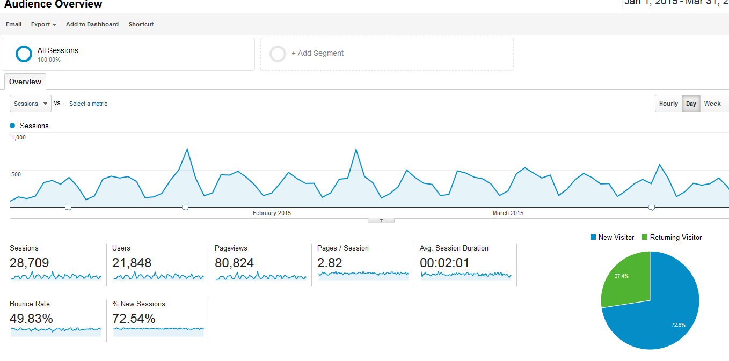
As the report indicates, during the quarter, the UChicago CCSR website was visited for 28,709 sessions (up 5,504 from the previous quarter). There were 21,848 users (up 4,087 from the previous quarter). This figure is based on IP addresses. To better illustrate the difference between sessions and users, consider the following example: If Jenny Nagaoka visited the UChicago CCSR website three times from her office computer, she would account for three visits and only one unique visit. If she visited the website three times from her office computer and once from her home computer, she would account for four visits and two unique visits. These unique visits are reset after one year for each IP address.

The report further indicates that the average number of pages visited on the website, per visit, is 2.82 (down 0.03 from the previous quarter). The bounce rate is 49.83% (down 2.58% from the previous quarter). A bounce rate is the percent of visitors who visit only one page on the website and then exit the website. They “bounce” on and off. Best practices generally indicate that a bounce rate below 50% is a good rate. This may not necessarily be true for UChicago CCSR, since a good visit might simply be someone reading a report, which can be done by going to a single page on the website, assuming the person visiting knows what that page is.

In addition to the audience overview above, Google Analytics allows users to run a number of personalized, individual reports based on their needs for the website. What follows are special reports, run specifically for UChicago CCSR needs.

Top Five Most Visited Pages
According to Google Analytics, during the quarter, the five most visited pages on the UChicago CCSR website are reported as follows:
Page | URL | Pageviews | Unique Pageviews
Homepage | http://ccsr.uchicago.edu/ | 8,236 | 6,712
2015 Survey Information | http://ccsr.uchicago.edu/page/2015-survey-information | 4,929 | 3,582
Publications Menu | http://ccsr.uchicago.edu/publications | 3,108 | 2,217
Survey Page | http://ccsr.uchicago.edu/surveys | 2,711 | 2,002
Noncognitive Report Landing Page | http://ccsr.uchicago.edu/publications/teaching-adolescents-become-learners-role-noncognitive-factors-shaping-school | 2,313 | 1,953

Top Five Most Downloaded Reports
Determining the top five most downloaded reports from the UChicago CCSR website is not a simple report. To do this, one must scroll through the list of every page accessed during the quarter, ranked by the number of visits, finding those pages ending in with the .pdf suffix. Not all pages with the .pdf suffix are reports. Among other things, they include press releases, job postings, and survey documentation. Knowledge of the organization and the website, however, makes it a simple matter of sorting out the reports from the other PDFs.

In addition, some reports are accessed by an http:// address and others are accessed by an https:// address. In order to get true counts, since each is considered a separate page by Google Analytics, both the numbers from the http:// version of the report and the https:// version of the report must be added together.

According to Google Analytics, during the January 1, 2015 to April 1, 2015 quarter, the following reports were the most downloaded from the website:
- Teaching Adolescents to Become Learners: The Role of Noncognitive Factors in Shaping School Performance (850 visits, 791 unique)
- Looking Forward to High School and College: Middle Grade Indicators of Readiness in Chicago Public Schools (521 visits, 470 unique)
- School Closings in Chicago: Understanding Families' Choices and Constraints for New School Enrollment (457 visits, 418 unique)
- The Educational Attainment of Chicago Public Schools Students: A Focus on Four-Year College Degrees (331 visits, 301 unique)
- Discipline Practices in Chicago Schools: Trends in the Use of Suspensions and Arrests (247 visits, 222 unique)

Geography of UChicago CCSR Website Visitors
Overwhelmingly, the vast majority of visitors to the UChicago CCSR website came from the United States (24,786 visits during the quarter, approximately 70% of all visits). The next top four countries, after the United States were the Philippines, Canada, India, and the United Kingdom.

Diving deeper into the analytics of US visitors, Google Analytics reveals that the vast majority of U.S. visitors are from Illinois. After Illinois, U.S. visitors come from California, New York, Texas, and Massachusetts, as illustrated from the report below:

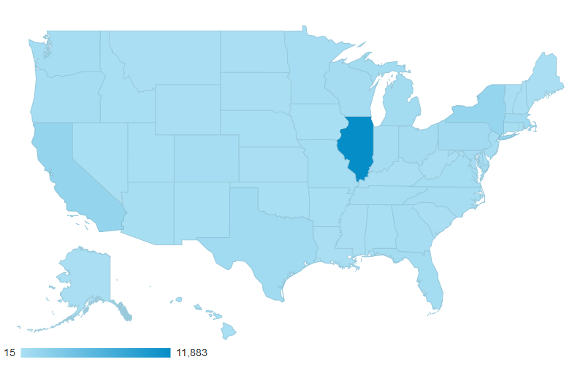
State | Sessions
Illinois | 11,883
California | 1,561
New York | 1,441
Texas | 631
Massachusetts | 614
Google Analytics can further analyze the location of audiences by city. In examining Illinois, the top five cities to channel visitors to the UChicago CCSR website include (not surprisingly) Chicago, Evanston, Oak Park, Wilmette, and Naperville.
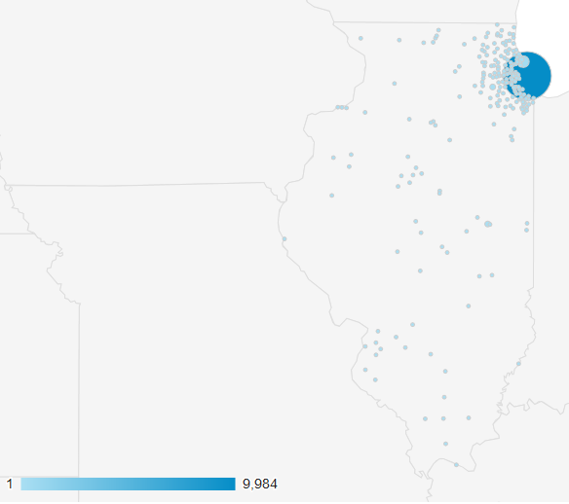
City | Sessions
Chicago | 9,984
Evanston | 424
Oak Park | 78
Wilmette | 44
Naperville | 43

Most visitors to the website view the website in English.

Sources of Site Traffic
Google Analytics offers a number of reports around traffic sources to the UChicago CCSR domain. The highest-level report indicates the percentages of visitors referred to the website by search engine (such as Google, Bing, Yahoo, etc.), direct traffic (people entering a UChicago web address directly into their browser or using a book-marked page), referral (someone clicking on a link from another website), email (e-blasts, etc.), and social media (Twitter, Facebook, etc.).

By far, the majority of traffic (59.9%, down 3.4% from the previous quarter) comes from search engines:
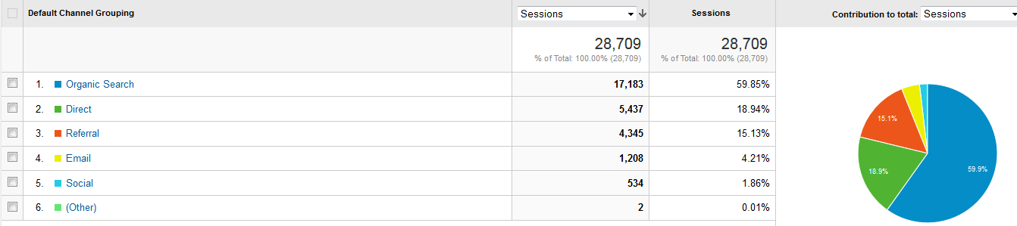
Direct traffic, which accounts for 18.9% (up 3.6% from the previous quarter) of traffic, cannot be tracked to original source. Either people are typing UChicago CCSR web addresses into their browsers or they have previously book-marked pages and are opening them directly. Google Analytics can allow users to see which specific pages are being accessed directly. For the UChicago CCSR domain, the top five directly accessed pages during the quarter were:
- The homepage
- The 2015 survey information page
- The landing page for the noncognitive report
- The landing page for authentic intellectual work
- The landing page for the 2015 school closings report

Referral traffic, which accounts for 15.1% (up 2.2% from the previous quarter) of traffic to the website, can be broken down by website. Below are the five most popular referral websites:
- cps.edu (955 referrals)
- uchicago.edu (233 referrals)
- uchicagoimpact.org (171 referrals)
- uei.uchicago.edu (159 referrals)
- attendanceworks.org (144 referrals)
Email traffic, accounting for 4.2% (down 1.2% from the previous quarter) of traffic, consists largely of UChicago CCSR e-blasts. The top five e-blasts to direct traffic to the UChicago CCSR domain during the quarter were:
- Middle Grades Brief Blast
- Discipline Blast
- School Closings Blast
- 2015-02-17 PRI (an external organization’s blast)
- Middle Grades Blast (a blast from last quarter)
Social media traffic, accounting for 1.9% (down 1.0% from the previous quarter) of traffic, can be broken down by type. Below are the five most popular social media referring sites:
- Twitter (255 referrals)
- Facebook (153 referrals)
- Hootsuite (41 referrals)
- tinyURL (16 referrals)
- Blogger (15 referrals)

